SUPPLEMENTARY MATERIAL
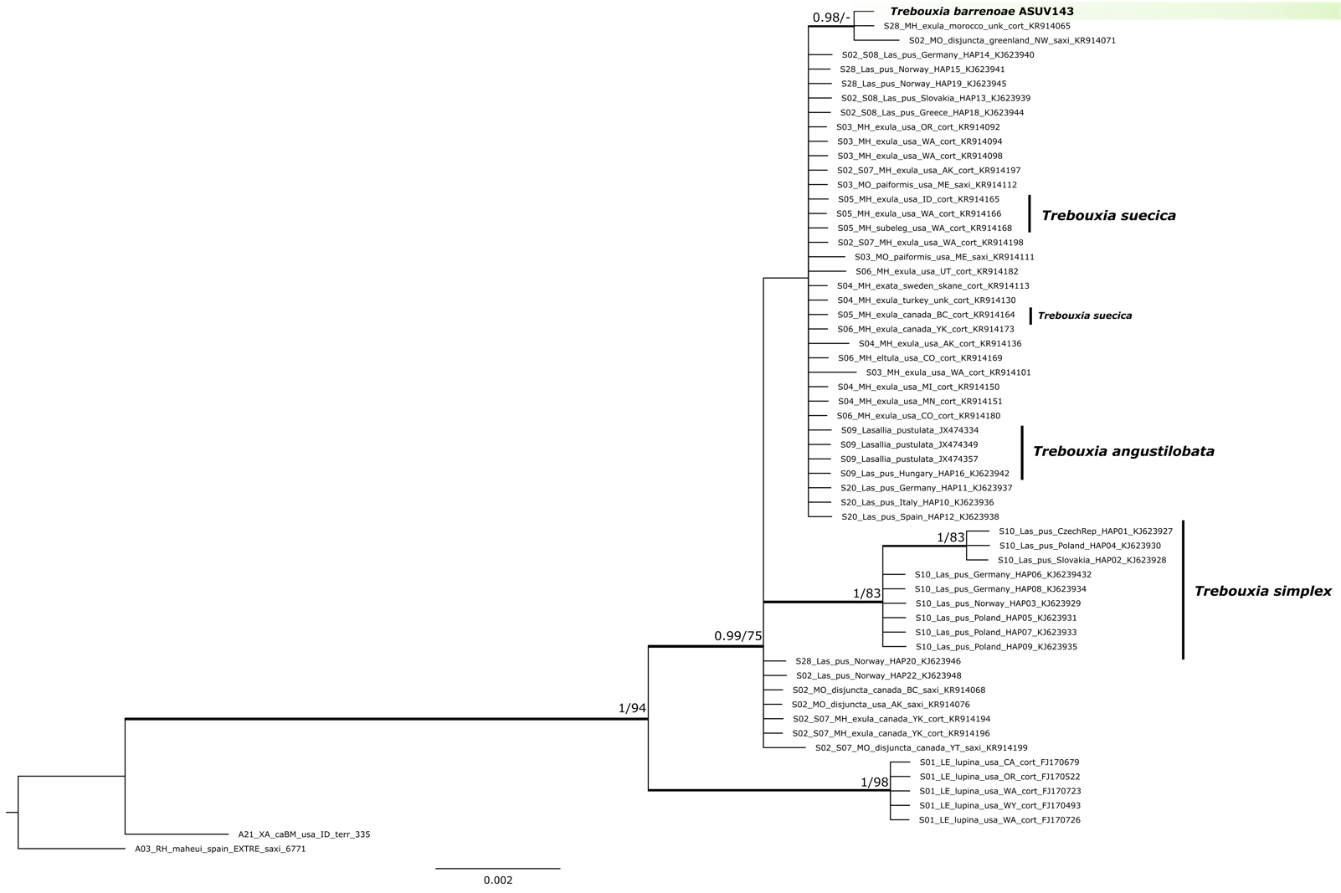
Supplementary Figure S1. MrBayes phylogram constructed using a rbcL marker dataset that represents 19 Trebouxia species-level lineages including sequences of four formally-described species stored at the algal collections SAG and UTEX. Each tip indicates the species code of each Trebouxia clade following Muggia et al. (2020). The new species Trebouxia barrenoae sp. nov. is highlighted in a green box. Thickened branches indicate bootstrap support (BS, RAxML) ≥ 70% and/or posterior probabilities (PP, MrBayes) ≥ 0.95. Species code for formally-described taxa is given in parenthesis.

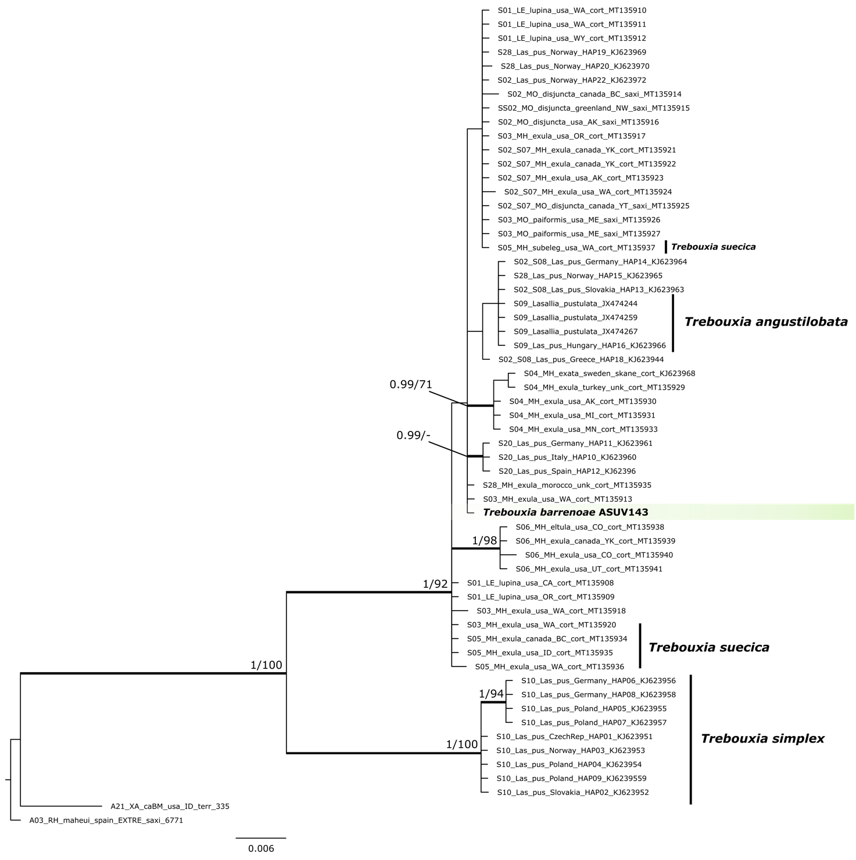
Supplementary Figure S2. MrBayes phylogram constructed using a cox2 marker dataset that represents 19 Trebouxia species-level lineages including sequences of four formally-described species stored at the algal collections SAG and UTEX. Each tip indicates the species code of each Trebouxia clade following Muggia et al. (2020). The new species Trebouxia barrenoae sp. nov. is highlighted in a green box. Thickened branches indicate bootstrap support (BS, RAxML) ≥ 70% and/or posterior probabilities (PP, MrBayes) ≥ 0.95. Species code for formally-described taxa is given in parenthesis.

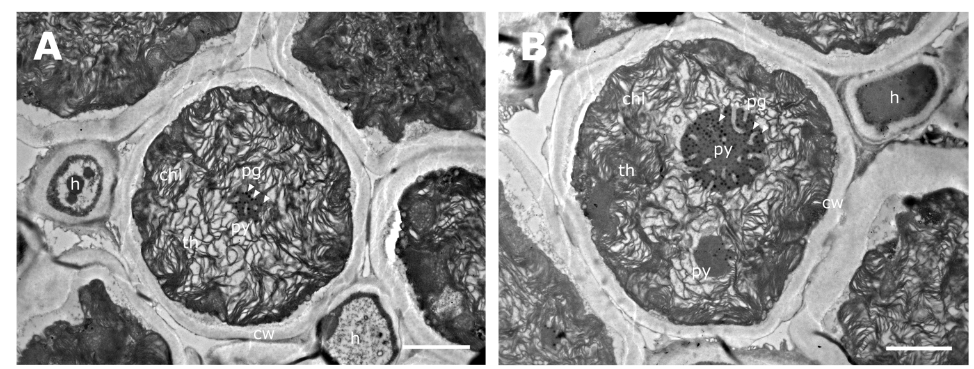
Supplementary Figure S3. Ultrastructure of Trebouxia barrenoae sp. nov. in symbiosis by TEM: A, B, mature cell within lichen thallus. Abbreviations: chl (chloroplast), cw (cell wall), h (hypha), pg (pyrenoglobules), py (pyrenoid), th (thylakoids). Scale bars: 2 μm. Reference strain: ASUV 143.

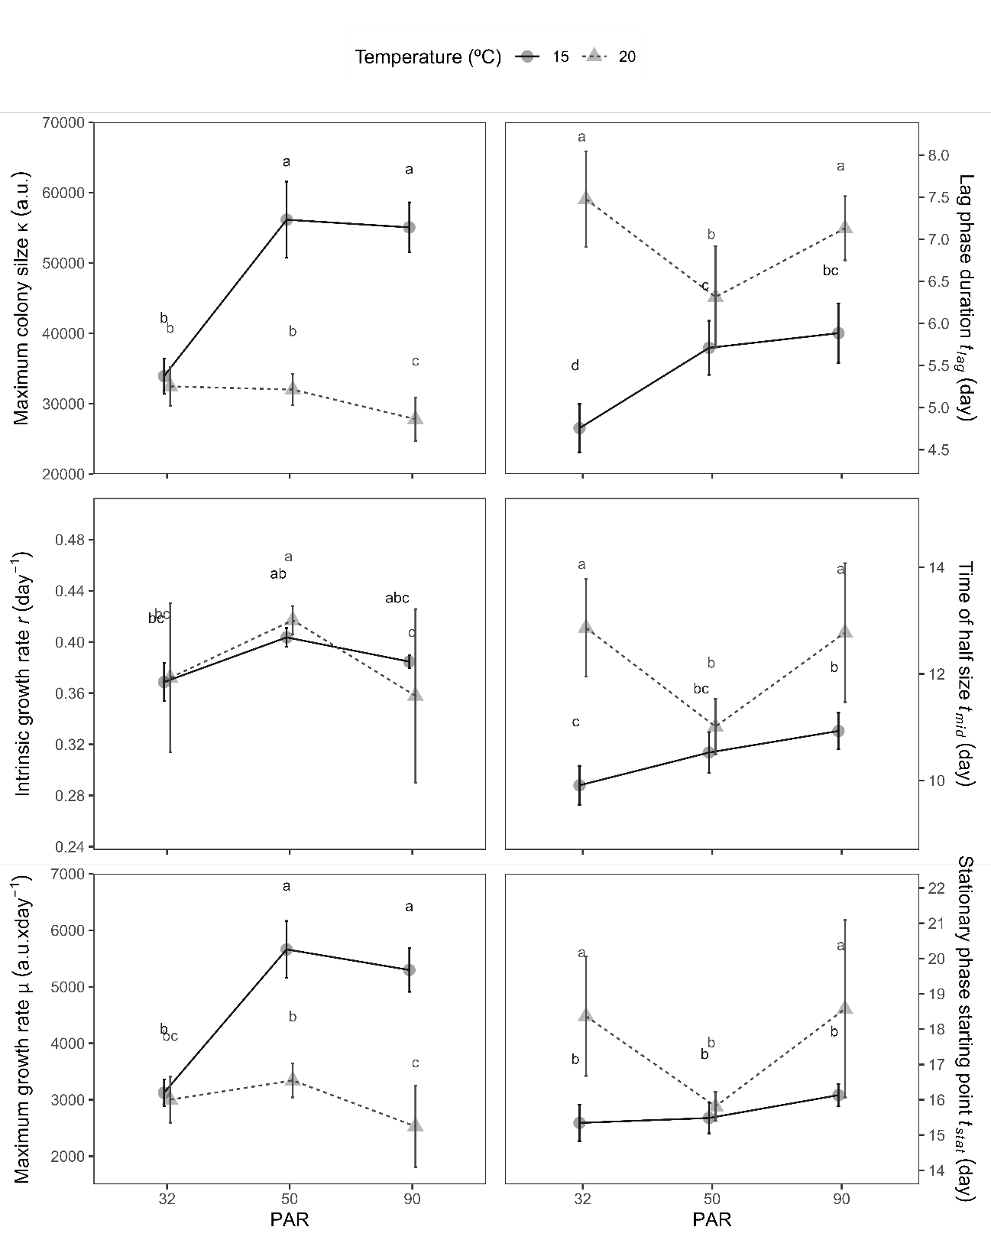
Supplementary Figure S4. Growth curves parameters of light intensity x temperature treatments. Data corresponds to the same as in Fig. 4. Points with the same letter are not statistically different (two-way ANOVA analysis, post hoc Tukey HSD test; p < 0.05; data represent mean ± standard deviation; n = 12).

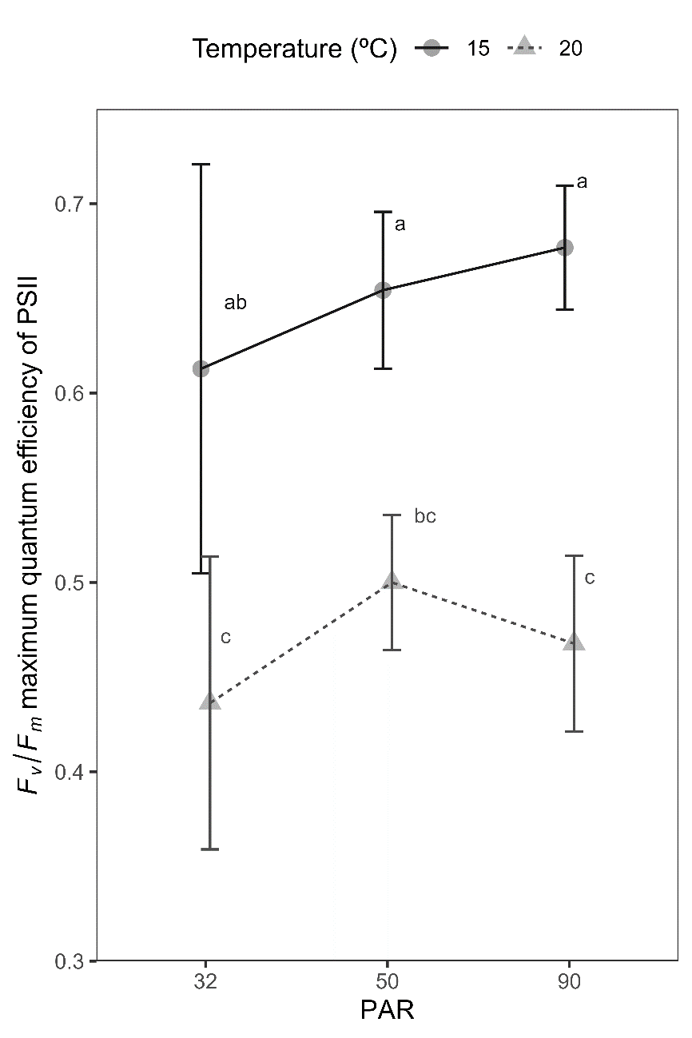
Supplementary Figure S5. Fv/Fm, maximum quantum efficiency of PSII photochemistry for the light radiation and temperature treatments. Measurements were taken after 21 days of growth. Points with the same letter are not statistically different (two-way ANOVA analysis, post hoc Tukey HSD test; p < 0.05; data represent mean ± standard deviation; n = 6).

